MED D - Digital Evidence of Coverage, Formulary and Pharmacy Directory

General Information
Requests for SilverScript EGWP / Blue MedicareRx (NEJE) Individual and EGWP
SilverScript Individual – Beneficiary Request – Plan Website
Blue MedicareRx (NEJE) Individual - Beneficiary Request - Plan Website
Aetna EGWP Non Part D Supplemental Benefit
FAQs
Sample Letters
Related Documents

Description: This document provides the steps for a CCR to request printed digital documents, including Evidence of Coverage, Formulary and Pharmacy Directory.

General Information
A portion of the ANOC packets will be available digitally to select clients:
- SilverScript Individual
- SilverScript EGWP
- Blue MedicareRx (NEJE) Individual
- Blue MedicareRx (NEJE) EGWP

HealthPlans are not included at this time.
Aetna EGWP: The Non Part D Supplemental Benefit (formerly known as rider) will no longer be part of the formulary guide. Instead will be available digitally. Refer to Aetna EGWP Non Part D Supplemental Benefit if the beneficiary requests a paper document.

Digital Documents:
- Evidence of Coverage (EOC)
- Formulary (Comprehensive)
- Pharmacy Directory

Paper Documents still being mailed as part of the Annual Notice of Changes (ANOC) booklet:
- Annual Notice of Changes
- LIS Rider
- Online Notice - Letter containing a URL directing beneficiaries to Digital Documents

Note: Refer to MED D - Fulfillment Request.

Top of the Document

Requests for SilverScript EGWP / Blue MedicareRx (NEJE) Individual and EGWP
If the beneficiary calls to request a copy of these documents to be sent to them via mail, perform the following:

Note: Spanish speaking beneficiaries will bypass the IVR and connect directly to a CCR. Refer to MED D - Language Assistance - Language Line Services.

Step | Action
1 | Authenticate the caller. Refer to Universal Care - Caller Authentication and HIPAA Authentication Grid.
2 | Would you like for me to request for you a copy of your Evidence of Coverage, Formulary (Comprehensive) and Pharmacy Directory be mailed to you?  Pause to allow beneficiary time to respond.  I can make the request for you right now.
3 | Access the (Find Med D EOB / TF from 6-2020) tool in PeopleSafe to determine if a copy has already been requested.  Refer to MED D - Viewing Correspondence and Requesting Reprints in PeopleSafe.
3 | If... |  | Then...
3 | Located |  | I can confirm that your request was mailed. You should receive your materials shortly.  Note: If the request was made within the past 3 days, then: Your materials have not yet been mailed. It may take an additional day for the item to be mailed. Please allow up to 10 business days from the date of your request.
3 | Not Located |  | Proceed to next step.
4 | Access the EOC, Formulary and Pharmacy Directory Request Portal to request the materials for the beneficiary.  - SilverScript Individual/Open: https://aetna-pdp.memberdoc.com  - SilverScript EGWP: https://silverscriptemployerpdp.memberdoc.com  - Blue MedicareRx (NEJE) Individual: https://rxmedicareplans.memberdoc.com  - Blue Medicare Rx (NEJE) EGWP: https://rxmedicareplans.memberdoc.com  HealthPlans are not included at this time.  Aetna EGWP: The Non Part D Supplemental Benefit (formerly known as rider) will no longer be part of the formulary guide. Instead will be available digitally. Refer to Aetna EGWP Non Part D Supplemental Benefit if the beneficiary requests a paper document.
5 | Enter Member ID.
6 | Enter ZipCode and select Submit.  If the below error message is received, verify the information was entered correctly.  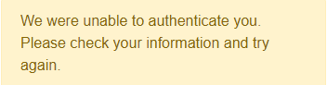  Note: If the beneficiary recently changed their address and their current Zip Code is not working, ask for their previous Zip Code as the system may not have been updated.
7 | Select appropriate year.  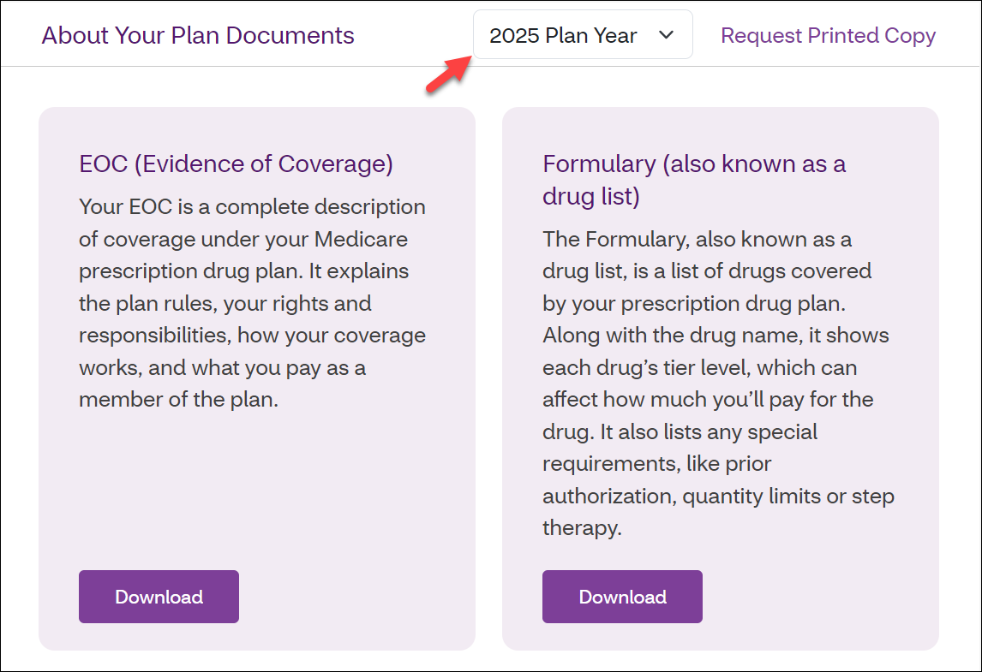
8 | Select Request Printed Copy.  Note: The beneficiary can also download the Evidence of Coverage, Formulary and/or Pharmacy Directory by selecting the down arrow next to applicable document.
9 | Do you need your plan documents by mail just this one time? Or would you like to get them by mail from now on?  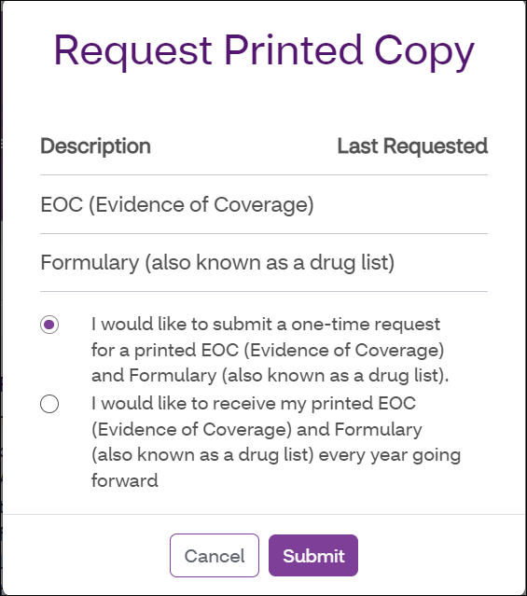
9 | If... |  | Then...
9 | One time |  | - Click the circle to the left of I would like to submit a one-time request for a printed EOC, Formulary and Pharmacy Directory.  - Proceed to next step.
9 | Annually |  | - Click the circle to the left of I would like received my printed EOC, Formulary and Pharmacy Directory every year going forward.  - Proceed to next step.
10 | Click the Submit button.  Thank You! The request has been submitted. It will take up to 3 days for your Evidence of Coverage, Formulary and Pharmacy Directory to appear in our files. You will receive the requested documents in approximately 10 business days. We will mail it to the address we have on file.
11 | Are there any other questions that I can assist with today?
11 | If… | Then…
11 | Yes | Assist the beneficiary with any questions using current policies and procedures.
11 | No | Proceed to the next step.
12 | It was a pleasure speaking with you. Good bye.

Top of the Document

SilverScript Individual – Beneficiary Request – Plan Website

Perform the following:
Step | Action
1 | Navigate to www.aetnamedicare.com.
2 | Select For Members.  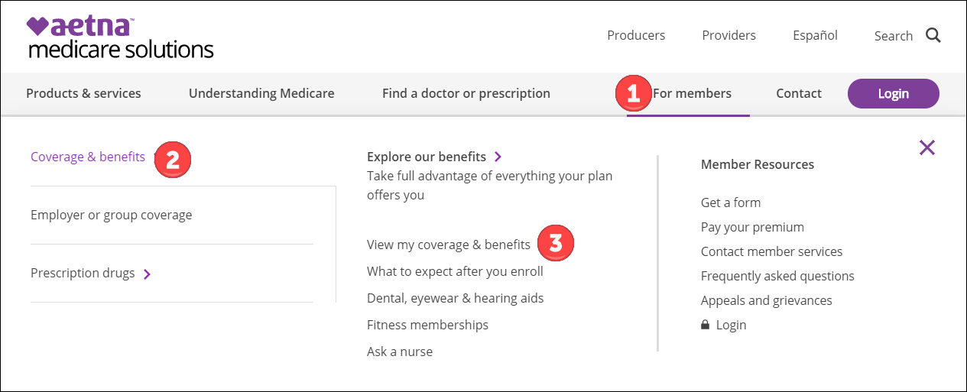
3 | Select Coverage & benefits.
4 | Select View my coverage & benefits.
5 | Directly under where you choose your location and plan to see plan documents, select the link: Prescription drug plan members (SilverScript Choice, Plus, or SmartSaver), you can request a copy of your Evidence of Coverage, formulary and pharmacy directory.  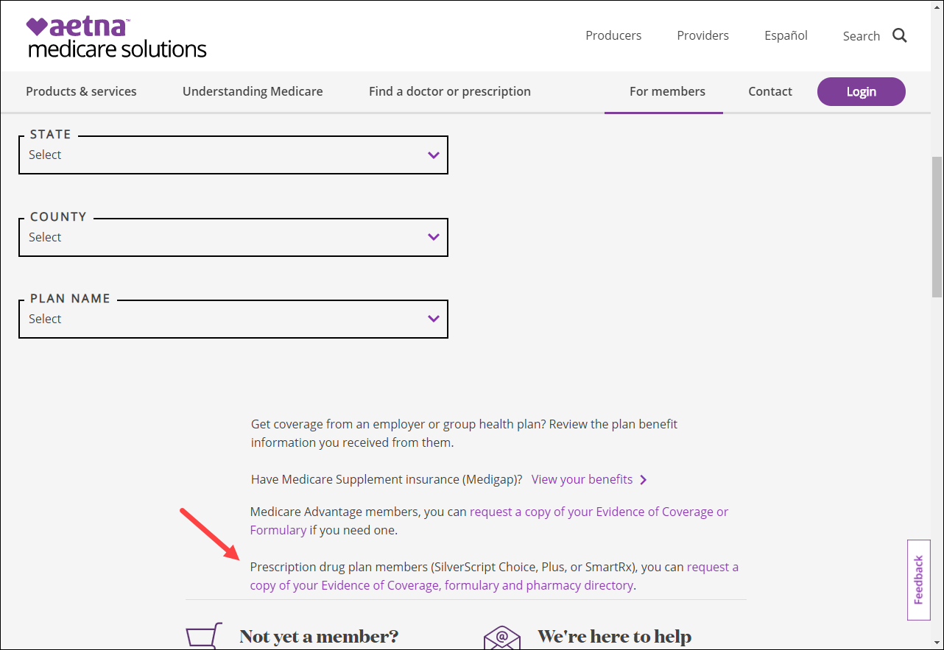
6 | Select Continue when advised you are now leaving the Aetna Medicare website.
7 | Enter Member ID.
8 | Enter ZipCode and select Submit.  If the below error message is received, verify the information was entered correctly.  Note: If the beneficiary recently changed their address and their current Zip Code is not working, ask for their previous Zip Code as the system may not have been updated.
9 | Select appropriate year.
10 | Select Request Printed Copy.  Note: The beneficiary can also download the Evidence of Coverage, Formulary and/or Pharmacy Directory by selecting the down arrow next to applicable document.
11 | Select if you would like to receive your plan documents by mail just this one time or if you would like to get them by mail from now on.
12 | Select Submit.

Top of the Document

Blue MedicareRx (NEJE) Individual - Beneficiary Request - Plan Website

Perform the following:
Step | Action
1 | Navigate to www.rxmedicareplans.com.
2 | Select Login to access your custom documents or select Members then New Members.  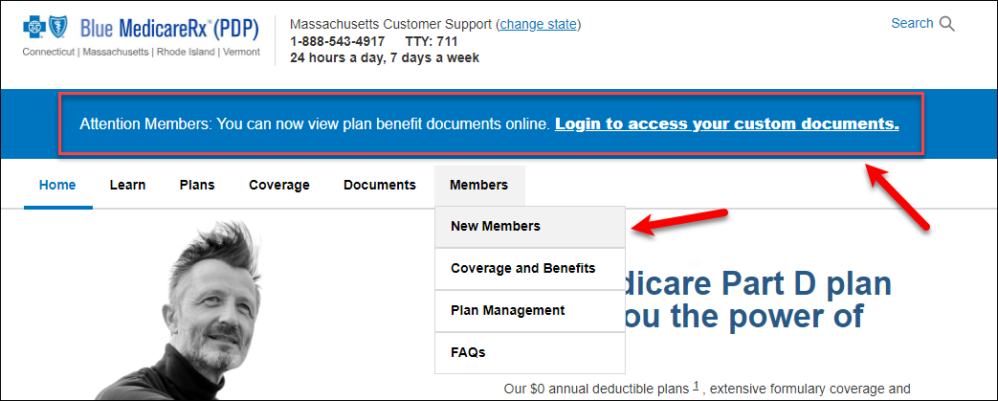
2 | If… | Then…
2 | Selecting Login to access your custom documents | Proceed to step 4.
2 | Selecting Members then New Members | Proceed to the next step.
3 | Directly under Blue MedicareRx Plan Materials, select the link: request a copy of your Evidence of Coverage, Formulary or Pharmacy Directory.  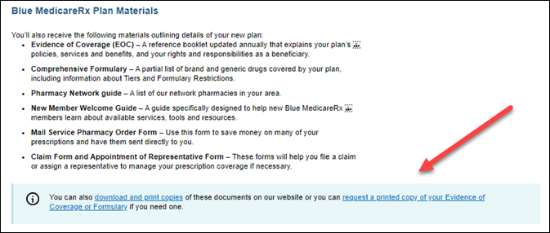  Continue to step 5.
4 | Select Continue when advised you are now leaving the Blue MedicareRx website.
5 | Enter Member ID.
6 | Enter ZipCode and select Submit.  If the below error message is received, verify the information was entered correctly.  Note: If the beneficiary recently changed their address and their current Zip Code is not working, ask for their previous Zip Code as the system may not have been updated.
7 | Select appropriate year.  Note: The beneficiary can also download the Evidence of Coverage, Formulary and/or Pharmacy Directory by selecting the down arrow next to applicable document.
8 | Select if you would like to receive your plan documents by mail just this one time or if you would like to get them by mail from now on.
9 | Select Submit.

Top of the Document

Aetna EGWP Non Part D Supplemental Benefit

Perform the following when the beneficiary requests the Non Part D Supplemental Benefit (formerly known as rider):
Step | Action
1 | Complete all areas of the Non Part D Supplemental Benefit Contact Form.
2 | Send completed email to MedicarePartDPharmacyOversight@AETNA.com.

Top of the Document

FAQs

Refer to the following:
Questions | Answer
Can I set up my digital preferences? | SilverScript Individual: SilverScript Individual - Beneficiary Request  SilverScript EGWP: Requests for SilverScript EGWP / Blue MedicareRx (NEJE) Individual and EGWP  BlueMedicare Rx (NEJE) Individual: Blue MedicareRx (NEJE) - Beneficiary Request  BlueMedicare RX (NEJE) EGWP: Requests for SilverScript EGWP / Blue MedicareRx (NEJE) Individual and EGWP
Can I set up my digital preferences in a foreign language? | - Currently we can only provide the select documents digitally in English.  - I can help request a paper version in a <non-English> language be mailed to you.  CCR Process Note: Refer to MED D - Fulfillment Request.
Why are some documents being sent digitally this year? | - This year we are focused on providing the member the option to obtain select document digitally.  - To improve the member experience, you will have the option to obtain these documents digitally or you can continue to receive as paper documents.
Why did I only receive part of my ANOC?  OR  Where is the rest of my ANOC? | - The Evidence of Coverage, Formulary and Pharmacy Directory were not included in the ANOC mailing this year.  - These documents will be available digitally this year.  - To improve our member experience, you will have the option to obtain these documents digitally or you can receive as paper documents.  - Would you like for me to request for you a copy of your Evidence of Coverage, Formulary (Comprehensive) and Pharmacy Directory be mailed to you?
Can I opt-out of receiving my documents digitally? | - Yes, you can opt-out of receiving your document digitally.  - I can help with that request today.
I did not receive my ANOC? What should I do? | - ANOCs began mailing on September 1, 2024.  - I can certainly help you, what is your current mailing address?  CCR Process Note: For help with pulling up a beneficiary’s ANOC in OneClick, refer to MED D - Viewing Correspondence and Requesting Reprints in PeopleSafe.  Note: Be sure to confirm the beneficiary’s eligibility to receive an ANOC, and update their mailing address if necessary.  CCR Process Note: Refer to MED D - Fulfillment Request.
I’m having issues with the telephone number process provided in the Material Notice letter. Can you help? | Assist the beneficiary by requesting the documents that they need.
I'm not able to request copies of the Evidence of Coverage, Formulary and Pharmacy Directory. | Assist the beneficiary by attempting to request copies. If unable to, send an email to MedDMCOTeam@CVSHealth.com to research the issue. Include the member ID and screen shot of error message received.

Top of the Document

Sample Letters
Refer to:
- MED D - SilverScript Digital Member Material Notice
- MED D - Blue MedicareRx (NEJE) Individual Digital Member Material Notice
- MED D - SilverScript EGWP Digital Member Material Notice
- MED D - Blue MedicareRx (NEJE) EGWP Digital Member Material Notice
Top of the Document

Related Documents
- Grievance Standard Verbiage (for use in Discussion with Beneficiary) section in MED D - Grievances Index.

Parent SOP: CALL-0048: Medicare Part D Customer Care Call Center Requirements-CVS Caremark Part D Services, L.L.C.
Abbreviations/Definitions: Abbreviations / Definitions

Top of the Document

Not to Be Reproduced or Disclosed to Others without Prior Written Approval
ELECTRONIC DATA = OFFICIAL VERSION – PAPER COPY = INFORMATIONAL ONLY

